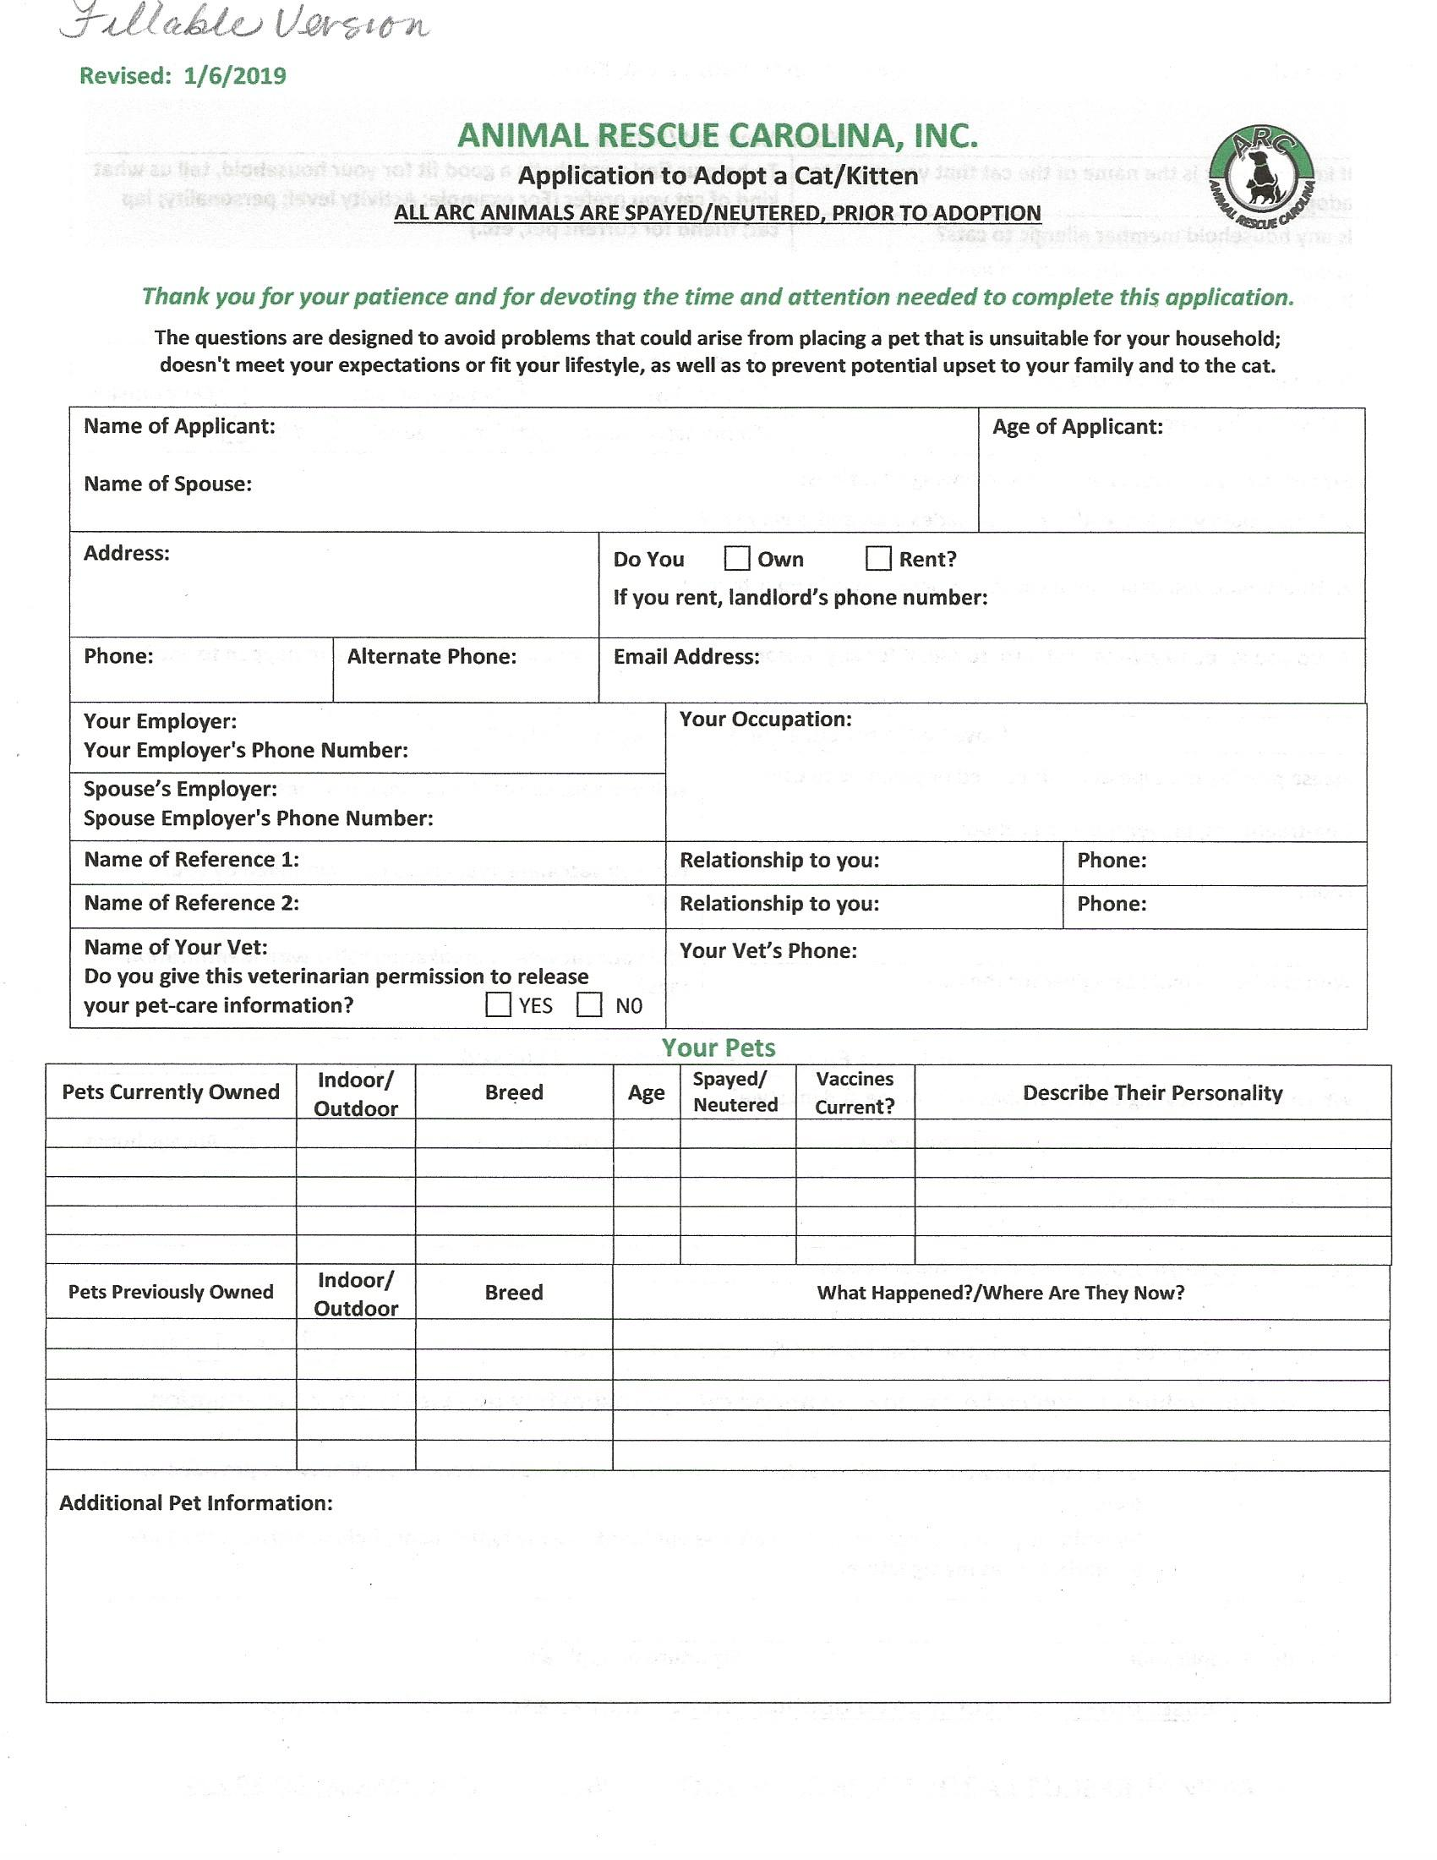
ANIMAL RESCUE CAROLINA, INC.
Application to Adopt a Dog/Puppy

ALL ARC ANIMALS ARE SPAYED/NEUTERED, PRIOR TO ADOPTION

Thank you for your patience and for devoting the time and attention needed to complete this application.

The questions are designed to avoid problems that could arise from placing a pet that is unsuitable for your household;
doesn't meet your expectations or fit your lifestyle, as well as to prevent potential upset to your family and to the dog.

Name of Applicant: |  |  |  | Age of Applicant:
Address: |  | Do You Own Rent?  If you rent, landlord’s phone number:
Phone: | Alternate Phone: | Email Address:
Your Employer:  Your Employer's Phone Number: |  |  | Your Occupation:
Name of Reference 1: |  |  | Relationship to you: |  | Phone:
Name of Reference 2: |  |  | Relationship to you: |  | Phone:
Name of Your Vet:  Do you give this veterinarian permission to release  your pet-care information? YES N0 |  |  | Your Vet’s Phone Number:
Your Pets
Pets Currently Owned | Indoor/  Outdoor | Breed |  | Age | Spayed/  Neutered??? | Vaccines  Current? | Describe Their Personality
Pets Previously Owned | Indoor/  Outdoor | Breed | What Happened?/Where Are They Now?
Additional Pet Information:

Your New Dog/Puppy
If known, what is the name of the dog that you want to adopt? | To help us find a dog that’s a good fit for your household, tell us what kind of dog you prefer (For example: Activity level; personality; jogging partner; friend for current pet, etc.)

Would you prefer a puppy, if available?
If yes, why?

Is any household member allergic to dogs?

Have you ever moved with a dog?  Will you be moving soon? | Where will the dog be kept?  Only inside Inside/outside Only outside

Will the dog/puppy be a gift for someone? YES N0

Explain how you would handle the following situations:

1. How would you deal with a dog that is not housebroken?

2. How would you deal with a dog that is destructive in your home?

3. Do you agree to give the dog back to ARC if for any reason it does not work out or if something were to happen to you?

How Will You Care for Your Adopted Dog/Puppy?
Please provide the type of product used or planning to use:  Heartworm prevention:  Flea-treatment/prevention medication:  Food: | Will you take the dog for an annual wellness exam?  Will you vaccinate your dog as recommended by your vet?  Will your dog wear a breakaway collar with identification tags?
Who will be the main caregiver for the dog?

Your Home Environment, Family and Lifestyle
Which of the following best describes your home and lifestyle?

Lively home Quiet home Out/travel a lot Always home

Who lives in your home?

Do you have a fenced yard? YES N0 If yes: What is the height of the fence?

Do you have a cat/dog door for indoor/outdoor access? YES N0

Do you give consent for a home visit by an ARC representative? YES NO

An ARC volunteer will make a follow-up phone call approximately two weeks after the adoption.

IMPORTANT: By signing below, I/we certify that there is no intentional deception and that all answers provided are true.

By typing my name, I represent that I am the applicant and my typed name, below, provides the same authorization as my signature.

Date of Application Signature of Applicant

Please, email your completed application to: animalrescuecarolina@yahoo.com

